« THE THIRD INDUSTRIAL REVOLUTION AND THE ENTREPRENEURS »
"Entrepreneurs: you take risks, you invest, you innovate,
you create jobs in France. Come and make your voice heard and talk! '

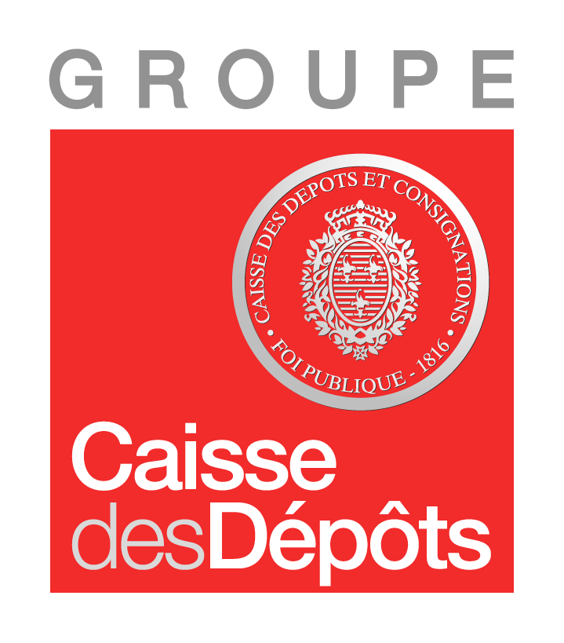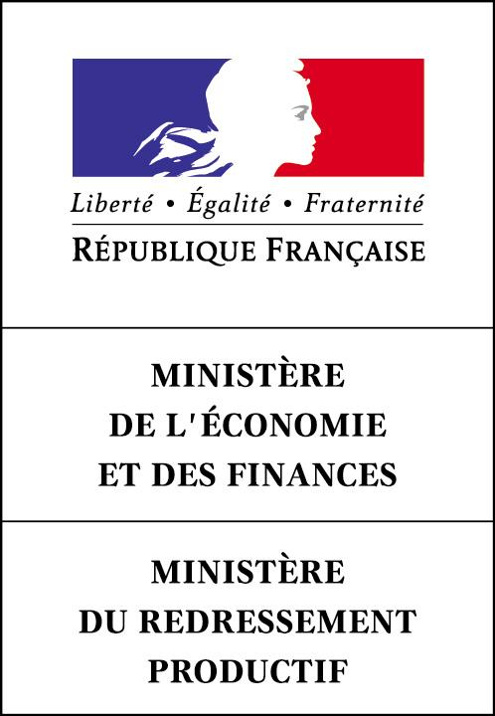5th Entrepreneurs Annual Conference
Paris, Monday November 12th 2012

Bercy, 139 rue de Bercy 75012 Paris
Centre de conférences Pierre Mendès France

In partnership with

8h45 / 9h20 – Opening keynote

- 8h45 / 9h10 : Pierre Moscovici, French Ministry of Economy and Finances : The role of entrepreneurs to build a human capitalism and a social-democracy able to meet the 21st Century ‘s challenge and young people’s aspirations
- 9h10 / 9h20 : Debate between Mr Moscovici and the G20 YES Entrepreneurs French delegation members with proposals to the French Government
- Frédéric Kulhmann, General Manager, Costral, Industrial equipment, Riquewihr
- Gilles Attaf, President, Smuggler, Textile industry, Limoges
- François Bieber, President, Net Affiliation, e-commerce, Bourg La Reine
- Laurence Onfroy, President, TemptingPlaces.com, e-commerce, Paris
- Hélène Saint Loubert, President, Grenade & Sparks, communication, Asnières

9h20/9h40 – Ramon Fernandez, French Treasury General Director : Grow our business by orientating long-term savings to increase the investment capacity of our SMEs and enhance competitiveness of the French economy

9h40 / 10h10 - Entrepreneurship and jobs creation, : which long term vision for France ?

- Debate between Arnaud Montebourg, French Minister of Industry Renewal and Laurence Parisot, Chairman of MEDEF

Exchange with the audience

10h10 / 10h30 - The 3rd industrial revolution and the entrepreneurs
- Grégoire Sentilhes, Journées de l’Entrepreneur & G20 YEA & NextStage President: Ouverture de la 5ème Conférence Annuelle des Entrepreneurs et de la 6ème edition des Journées de l’Entrepreneur en France “To hear the entrepreneurs’ voice and understand they are key to building the economy of the 21st century?”

10h30 / 11h20 – Nurture an entrepreneurial ecosystem for the growth of entrepreneurs

- 10h30 / 10h50 : Debate between Dan Serfaty, co-Founder and President, Viadeo, reflexions of a French entrepreneur living in China and Antoine Gosset-Grainville, Deputy General Manager, Caisse des Dépôts

- 10h50/ 11h20 : Roundtable discussion :

- Jean David Chamboredon, General Manager of ISAI and “spokesman of the pigeons movement”
- Jean-Pierre Letartre, CEO, Ernst & Young France, and presentation of Ernst & Young study« 20 years of entrepreneurial success in France” published for the “20 years of the Entrepreneur of the Year” event.
- Catherine Barbaroux, ADIE President
- Christophe Schmitt, Dean of the Students Entrepreneurship Center of the Lorraine University
- Blandine Herbaut-Mulliez, President - Foundation Entreprendre
- Martine Liautaud, Liautaud & Cie, CEO and Founder, WBMI (Women Business Mentoring Initiative) Founder

Exchange with the audience

11h20/11h40 – Break

11h40 / 11h55 - Joanna Drake, European Commissioner DG Enterprise & Industry, Directorate SME’S & Entrepreneurship : European Commission proposals to put the entrepreneurs at the heart of European economic model as they represent 85 % of the jobs creation for 2002/2010 period.

11h55 / 12h40 : Do banks in France play their role vis-à-vis SME businesses and how do they innovate in this unstable environment to fund small businesses development?
- Yves Perrier, General Manager, Amundi
- Thierry Willième, President, GE Capital France
- François Essertel, President, Credit Suisse (France)
- Daniel Karyotis, Président de la Banque Palatine
- Oliver Dhonte, President, Information and communication technologies, Viséo
- Nathalie Court, President, Pole de prevention et d’assistance à la personne

12h40 / 14h15 – Lunch Break – Cocktail and networking

14h15 / 15h – Analysis grid on performing entrepreneurial ecosystem

- Daniel Isenberg, Babson Global College, Author of « How to start an entrepreneurial revolution? » HBR June 2010 « case study»

14h45 / 15h – Exchange with the audience

15h / 16h – To help small businesses to become medium size enterprises in order to be listed at the stock market for the most innovative ones.
- Pierre Gattaz, President, FIEEC (Federation of electrical, electronic and communication industries) « It’s hard to be a great business leader in France - why it still should be possible »
- Luc Rousseau, General Manager of French Government Industrial Department : « Why the industrial ambition of France and the entrepreneurial culture must converge and become one”
- Olivier Duha, CroissancePlus, President and Webhelp cofounder
- Jean-Yves Gilet, FSI General Manager
- François Drouin, President, Oseo
- Pierre Nougué, Co-Founder, Ecosys and Les Journées de l’Entrepreneur, Vice Chairman

16h / 16h20 – Break

16h20 / 16h50 – Key recommendations for a “new entrepreneurial deal” for France

- Debate between Fleur Pellerin, French Minister in charge of SME’s, Innovation and Digital Economy and Philippe Hayat, 100 000 Entrepreneurs President, author of « for a new entrepreneurial deal » study

Exchange with the audience

16h50 / 17h30 – Which are the stock markets in France that work (NYSE Euronext, France Investissement) to fund listed/unlisted SMEs and what is the newly created BPI role tomorrow with the private market?

- Dominique Cerutti, NYSE Euronext President
- Miles Kirby, Managing Director Qualcomm Ventures Europe
- Thierry Giami, CDC Manager, co-author of the SME’s businesses
- Philippe Braidy, President, CDC Entreprises and Co-President, France Investissement
- Louis Godron, President, French Association of Investors for Growth
- Arnaud Caudoux, Chief Operating Officer, Oseo

17h30 / 17h45

- Jean-François Roubaud, CGPME President

17h45 / 18h15– Closing keynote :

Conclusions and remarks about the conference with 6 entrepreneurs of the G20 YES in Mexico French delegation:
- Nicolas Rohr, President, Faguo, e-commerce, Paris
- Florence Haxel, President, La Tribu des Créateurs, Events, Paris
- Jean Michel Berud, President, Jifmar, maintenance of offshore oil terminals, Marseille
- Florence Hallouin, Co-Founder, Hamac, ecological textile, Paris
- Philippe Deljurie, Cofounder, MeteoJob, e-recruitment, Paris
- Emmanuel Cotsoyannis, Manager, Les Diners d’Eloîse, Paris

Jérôme Cahuzac, Minister of budget : «"For a fair taxation and for a social model, put entrepreneurs at the heart of economy of France for the 21st Century"

